 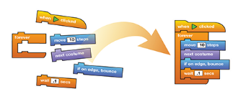

Fun Introduction to Coding

For kids in 3-5th Grades

*“Learn how to program a computer — because it teaches you how to think.”*

-Steve Jobs

This workshop teaches kids basics of computer programming using various visual programming tools. In addition to teaching kids the basics of coding, the program teaches them to develop stories, games, puzzles and animations.

Visit www.mathandcoding.org for more information. This program is mainly targeted for kids with very little or no previous experience with Scratch, Tynker or any other coding languages.

Space is limited to 20 kids and registration for this free program begins on…..

For more information call …or email ……

~~On Saturdays between 3.00 – 4.30 pm, 01/24 – 02/14~~

**~~SUNNYVALE~~ PUBLIC LIBRARY**